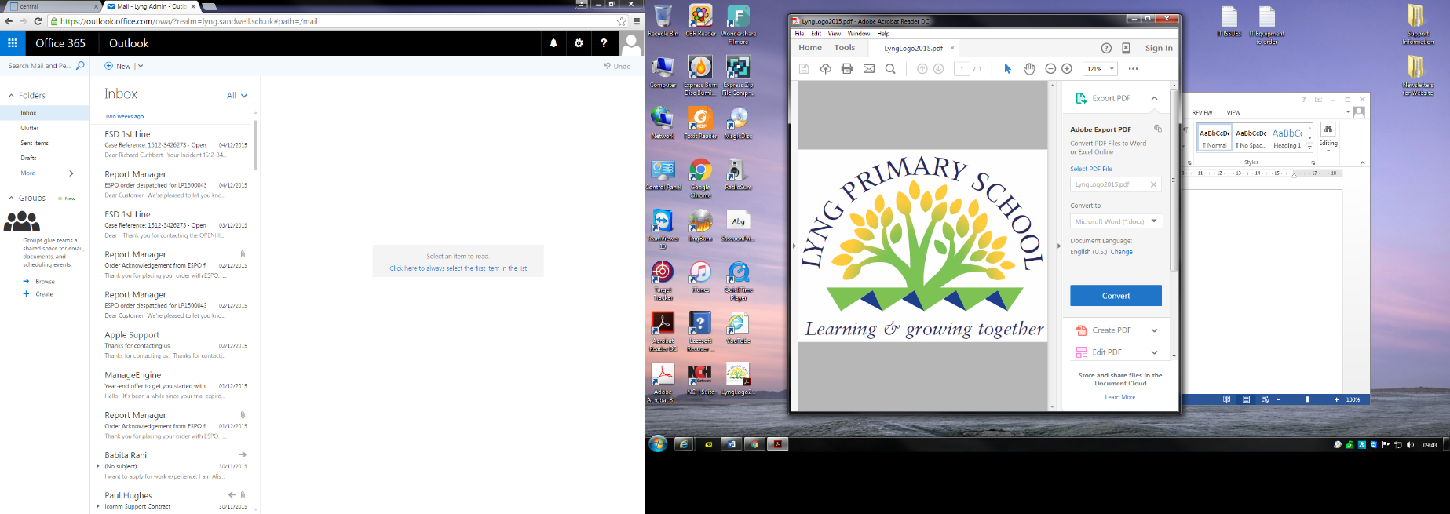

Headteacher: Mr A Fowler

Horton Street, West Bromwich, West Midlands, B70 7SQ.

Telephone: 0121 553 1480 - Email: [lyng.admin@lyng.sandwell.sch.uk](mailto:lyng.admin@lyng.sandwell.sch.uk) - Website: www.lyng.sandwell.sch.uk

**Main Scale Teacher Vacancy from Summer Term 2025**

Lyng Primary is a two form entry Primary school, rated Good by Ofsted in 2016 and rapidly moving towards Outstanding.

This is a fantastic opportunity to work in our school, to ‘make a difference’ to enhance children’s lives and continue to drive the school forward.

The successful candidates will:

• Be enthusiastic about teaching and learning.

• Be committed to raising standards

• Be a consistently good/outstanding teacher.

• Be able to inspire and motivate

• Be able to demonstrate excellent classroom practice

We can offer:

• a welcoming community

• happy, friendly, enthusiastic and well-behaved children

• excellent opportunities for continuing professional development

• supportive and hard-working colleagues

• an active and supportive Governing Body

If you are interested in applying for the post, please complete the application and return to Lyng Primary or [Victoria.durnall@lyng.sandwell.sch.uk](mailto:Victoria.durnall@lyng.sandwell.sch.uk)

**Safeguarding**

Lyng Primary School is committed to safeguarding and promoting the welfare of children.  We will ensure that all our recruitment and selection practices reflect this vision. Successful candidates will be subject to an Enhanced DBS check along with other relevant safeguarding and employment checks.  Sandwell MBC is an Equal Opportunities employer.

This post is exempt from the Rehabilitation of Offenders Act 1974 and is eligible for an enhanced DBS check including a Children's Barring List Check. If you are barred from working with children you are breaking the law if you apply for this post.  Shortlisted candidates applying for a regulated activity role will be asked to complete a self-declaration and disclosure form.  Any disclosures declared on this form will be discussed at interview.

A copy of the School’s Child Protection and Recruitment and Selection Policy and Guidance can be found on our website.

This post is covered by Part 7 of the Immigration Act (2016) and therefore the ability to speak fluent and spoken English is an essential requirement for this role

Please ensure all application forms are signed when sending via email.

If you are successful in being short-listed for interview, you will be contacted via email within 28 working days of the closing date. Please ensure you check your junk/spam boxes as well as your inbox in case any correspondence has been delivered there.

**Online Search**

An online search will be undertaken on all shortlisted candidates. This search does not form part of the shortlisting process and you will have the opportunity to discuss any issues of concern that may arise from this search at the interview.

**Closing Date Monday 10th February 2025**

